EDITORIAL NOTE – 2024 SCHOLARLY REVISION
This document has been peer-reviewed and revised by faculty to align with current international evidence-based guidelines, including the American Society of Colon and Rectal Surgeons (ASCRS) Clinical Practice Guidelines for the management of anal fissures, hemorrhoids, and anorectal abscess/fistula, and the NANDA International (NANDA-I) 2021-2023 Nursing Diagnoses taxonomy. Convention: original content is shown in standard black text; all revised, corrected, expanded, or newly added content is shown in BOLD BLUE text so that every enhancement is immediately identifiable to readers.



Faculty of nursing Medical Surgical Nursing Medical Surgical II Course Surgical rotation 2022/2023

Anorectal Disorders

Prepared by:
Dr/ Asmaa Abdel Hafez Dr/ Yasser Mahmoud

1

- Outlines:

- Introduction
- Anatomy of anal canal.
- Incidence of anal conditions.
- Common conditions of the anorectal area:
  - Anorectal Abscess
  - Anal Fistula
  - Anal Fissure
  - Hemorrhoids (piles)
- Pathophysiology of each condition.
- Manifestations of each condition.
- Complications of each condition
- Conservative and surgical treatment of each condition
- Nursing care of each condition.
- Health education of each condition.
Diagnostic evaluation and evidence-based management updates.
Application of the nursing process (assessment, diagnosis, planning, implementation, evaluation).
- Common nursing diagnosis with anorectal disorders

Introduction:
Anorectal disorders are a group of medical disorders that occur at the junction of the anal canal and the rectum. Anorectal disorders are common. Patients with anorectal disorders seek medical care primarily because of pain, rectal bleeding, or change in bowel habits. Other common complaints are protrusion of hemorrhoids, anal discharge, perianal itching, swelling, anal tenderness, stenosis, and ulceration. Constipation results from delaying defecation because of anorectal pain. Anorectal disorders encompass a broad spectrum of benign and, less commonly, malignant conditions affecting the anal canal, anal margin, and distal rectum; the four conditions addressed in this chapter (abscess, fistula, fissure, and hemorrhoids) are the most frequently encountered in medical-surgical practice. Because these conditions share overlapping risk factors (notably constipation, low dietary fiber intake, and prolonged straining), a single patient may present with more than one condition simultaneously, which has important implications for nursing assessment and care planning.
The prevalence of anorectal disorders varies, mainly due to wrong attribution of anorectal symptoms. The estimated worldwide prevalence of Hemorrhoidal disease ranges from 2.9% to 27.9%, more than 4% of which are symptomatic. Female patients are less frequently affected than male. (Lohsiriwat, 2012; Sun & Migaly, 2016). Nurses play a central role in early recognition of anorectal symptoms, as patient embarrassment and stigma often delay presentation and worsen outcomes; a non-judgmental, private, and culturally sensitive approach to history-taking and physical assessment improves diagnostic accuracy and patient trust.

Anatomy and physiology of anal canal:
- The anal canal is the last part of the gastrointestinal tract. It is about 3 to 4 cm long and lies completely extraperitoneal. It begins at the anorectal junction distally from the perineal flexure and ends at the anus. The dentate (pectinate) line, located roughly at the midpoint of the anal canal, is a clinically critical landmark: tissue above it is innervated by the autonomic nervous system and is relatively insensitive to pain, whereas tissue below it is innervated by somatic (pudendal) nerves and is highly pain-sensitive. This explains why internal hemorrhoids (above the line) are typically painless, while external hemorrhoids, fissures, and abscesses affecting tissue below the line are markedly painful.
- A network of striated muscle that forms both the internal and the external anal sphincters regulates the anal outlet which control defecation. Adequate resting tone of these sphincters maintains continence, while their coordinated relaxation during defecation, together with increased rectal pressure (Valsalva maneuver), permits evacuation.
- Blood supply is via the superior, middle, and inferior rectal arteries (branches of the inferior mesenteric, internal iliac, and internal pudendal arteries, respectively). Venous drainage differs above and below the dentate line: above the line, blood drains via the superior rectal vein into the portal venous system (inferior mesenteric vein → portal vein → liver → hepatic veins → inferior vena cava); below the line, blood drains via the middle and inferior rectal veins directly into the internal iliac veins and then the inferior vena cava, bypassing the liver. This dual drainage explains why thrombosed internal hemorrhoids can occasionally be a route for portal-systemic anastomosis in portal hypertension.
- Nerve supply above the dentate line is autonomic, from the inferior mesenteric (hypogastric) plexus, and is largely insensate to touch and pain (sensitive only to stretch). Below the dentate line, sensory innervation is somatic, via the inferior rectal branch of the pudendal nerve (S2-S4), making this region acutely sensitive to pain, touch, and temperature - a key rationale for administering adequate analgesia before examining or dressing this area.
- Anal sphincters:
- Internal sphincter is circular muscle coat of the rectum. it starts where the rectum passes through the pelvic diaphragm and surrounds the anal canal, It is innervated by the autonomic nervous system and therefore is not under voluntary control; chronic hypertonicity (spasm) of the internal sphincter is now recognized as the primary pathophysiological mechanism underlying chronic anal fissure.

spasm of this muscle plays a major role in anal fissure, Longitudinal muscle is a visceral (involuntary).
- External sphincter is a somatic (voluntary) muscle that forms the outermost muscular cylinder.
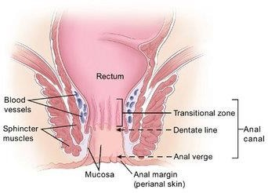

Table: Clinically Important Differences Above vs. Below the Dentate Line
Feature | Above the Dentate Line | Below the Dentate Line
Embryologic origin | Endoderm (hindgut) | Ectoderm (proctodeum)
Epithelium | Columnar epithelium | Squamous epithelium (anoderm)
Innervation | Autonomic (insensate to pain) | Somatic - pudendal nerve (pain-sensitive)
Venous drainage | Portal system (superior rectal vein) | Systemic system (middle/inferior rectal veins)
Lymphatic drainage | Internal iliac nodes | Superficial inguinal nodes
Related hemorrhoid type | Internal hemorrhoids (usually painless) | External hemorrhoids (painful if thrombosed)

Common Anorectal Disorders:
- Anorectal Abscess
- Anal Fistula
- Anal Fissure
- Hemorrhoids (piles)

Anorectal Abscess:
An anorectal abscess refers to a collection of pus in the anal or rectal region. They are more common in men than in women and have high rates of recurrence. Most abscesses originate from an infected anal gland (cryptoglandular origin), and if left untreated, more than one-third progress to form a chronic anal fistula.

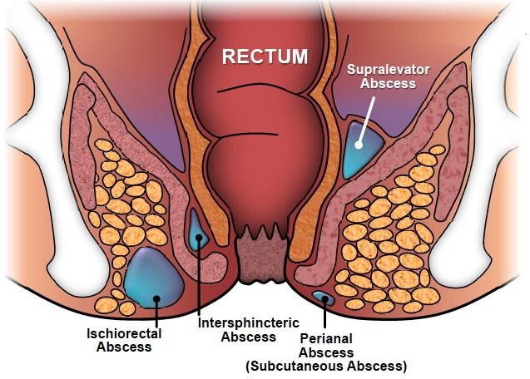

Pathophysiology of anorectal abscess: -
Anorectal abscess is thought to be caused by plugging of the anal ducts, the ducts that drain the anal glands in the anal wall, helping to ease the passage of fecal matter through mucus secretion.
Blockage of an anal duct results in fluid stasis, which will lead to infection.
Common causative organisms include E. coli, and Enterococcus bacteria.
The anal glands are located in the intersphincteric space (between the internal and external anal sphincters), therefore infection from the glands here spreads to adjacent areas.
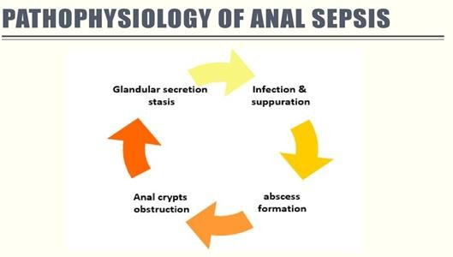

Classification by anatomic space (Parks classification): perianal (most common, ~40-50%), ischiorectal, intersphincteric, and supralevator abscess (least common but most serious, may mimic pelvic pathology).

Risk factors:
People with Crohn's disease or immunosuppressive conditions (e.g., diabetes mellitus, HIV infection, corticosteroid or biologic therapy), pre-existing fistula, anal fissure, or hemorrhoids are at increased risk. Additional recognized risk factors include obesity, prolonged sitting/immobility, receptive anal intercourse, and foreign body insertion.

Clinical Features:
- Pain in the perianal region, which becomes exacerbated when sat down.
- Localized swelling,
- Itching, or discharge
- Severe abscesses may present with systemic features* such as fever, rigors, general malaise, or features of sepsis. Deep abscesses (e.g., supralevator) may present with vague pelvic or lower abdominal pain and few external signs, delaying diagnosis; a high index of suspicion is required in immunosuppressed or diabetic patients.

Complications:
  - Fistula
  - Perianal sepsis
  - Necrotizing soft tissue
  - Infection of the anus and surrounding buttock

Management:
- Examination through inspection and digital rectal examination.
- Patients should be started on antibiotic therapy, as guided by local protocol, and provided with sufficient analgesia. Antibiotics alone (without drainage) are inadequate and should never replace surgical drainage, as abscess pus is inaccessible to systemic antibiotic penetration.
- The definitive management for anorectal abscess is prompt incision and drainage (I&D); delaying drainage in favor of antibiotics alone risks progression to sepsis and tissue necrosis. Small, superficial (perianal) abscesses can often be drained under local anesthesia in an outpatient/clinic setting, whereas larger, deep, or complex abscesses (ischiorectal, supralevator) typically require drainage in the operating room under regional or general anesthesia to ensure adequate exploration and pain control. Routine antibiotics are not required after simple drainage in an immunocompetent patient unless there is extensive cellulitis, systemic signs of infection, immunosuppression, or underlying valvular heart disease/prosthetic material.
- Once drained, proctoscopy should be performed to check for the presence of any identifiable fistula.

Nursing care:
- Health education for gentle perineal hygiene and dryness.
- Wear cotton clothes.
- Sitz- baths.

Assess the surgical/drainage site for bleeding, wound breakdown, or foul-smelling discharge suggestive of an evolving fistula, and report promptly.
Administer analgesia proactively, ideally 30 minutes before dressing changes or sitz baths, and before bowel movements, to minimize pain-related fear of defecation and consequent constipation.
Encourage a high-fiber diet (25-30 g/day) and 2-3 L/day of fluid, and administer stool softeners as prescribed, to prevent straining and wound trauma during defecation.
Teach the patient and family the signs of recurrent infection or fistula formation (persistent drainage, recurrent swelling, pain) that warrant follow-up.

Anal Fistula:
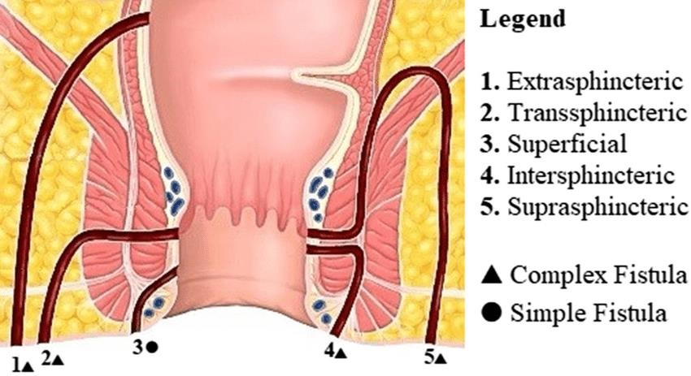An anal fistula is a tiny, tubular, fibrous tract that extends into the anal canal from an opening located beside the anus in the perianal skin. Approximately 90% of fistulas are cryptoglandular in origin, arising from an antecedent anorectal abscess; the fistula tract essentially represents the epithelialized residual drainage pathway of the original infection.
Park's Classification | Description
Intersphincteric | Tract passes only through the internal sphincter (most common, ~70%).
Trans-sphincteric | Tract crosses both internal and external sphincters.
Supra-sphincteric | Tract passes above the puborectalis muscle before descending to the skin.
Extra-sphincteric | Tract bypasses the sphincter complex entirely, often from pelvic/rectal disease (rare).
Goodsall's Rule (clinically useful for predicting internal opening location): fistulas with an external opening anterior to a transverse line through the anus tend to track in a straight radial line to the dentate line; fistulas with a posterior external opening tend to follow a curved course to an internal opening in the posterior midline.

Risk factors:
- Infection
- Trauma
- Fissures
- Crohn’s disease Other causes include tuberculosis, malignancy, radiation proctitis, and prior anorectal surgery.

Clinical feature: -
- Purulent drainage or stool may leak constantly from the cutaneous opening. Passage of flatus or feces from the vagina or bladder, depending on the location of the fistula tract.

Complications:
- Infection
- Bowel incontinence
- Recurrence of the fistula

Management:
- Diagnosis: through inspection, digital rectal examination, MRI in some cases

- Medical management: Antibiotics or anti-inflammatory type agents (e.g., azathioprine, infliximab, cyclosporine).
- Surgical treatment: because recurrence is common, surgery is recommended, as few fistulas heal spontaneously. Surgical options are selected according to the amount of sphincter muscle involved and the risk of incontinence: fistulotomy/fistulectomy (laying open the tract) for simple, low fistulas; a seton (draining or cutting) for complex or high trans-sphincteric fistulas to allow gradual, controlled division of the sphincter or long-term drainage; and sphincter-sparing techniques - the ligation of the intersphincteric fistula tract (LIFT) procedure, endorectal advancement flap, and fibrin glue or bioprosthetic fistula plug - for complex fistulas where preserving continence is a priority.

Nursing care:
- Frequent observation of the discharge from perineal area. and note characteristics (color, odor, amount, consistency) to detect complications early.
- Health education for gentle perineal hygiene and dryness.
- Wear cotton clothes.
- Sitz baths.
- Remove the pack as ordered after warm sitz bath gently.
- Avoid strain as in constipation, accumulation of gases…etc.
- Increase fiber and fluid intake.
- Avoid overuse of laxatives.

Provide emotional support and reassurance, as chronic drainage and odor can cause embarrassment, social withdrawal, and altered body image; involve the patient in care decisions.
If a seton is in place, teach the patient that mild ongoing drainage is expected and instruct on the use of a perianal pad and barrier cream to protect the skin.

Anal Fissure:
An anal fissure is a tear in the mucosal lining of the anal canal. It can be classified according to its duration: Most fissures (roughly 90%) occur in the posterior midline of the anal canal, an area with relatively poor blood supply, which impairs healing once a tear occurs; anterior midline fissures are more common in women, particularly after vaginal childbirth. Fissures occurring off the midline should raise suspicion for an underlying cause such as Crohn's disease, tuberculosis, HIV infection, or malignancy.
Acute – present for < 6 weeks. Chronic – present for > 6 weeks. A self-perpetuating cycle develops in chronic fissures: pain from the tear causes reflex spasm of the internal anal sphincter, which further reduces blood flow to the fissure bed and prevents healing.
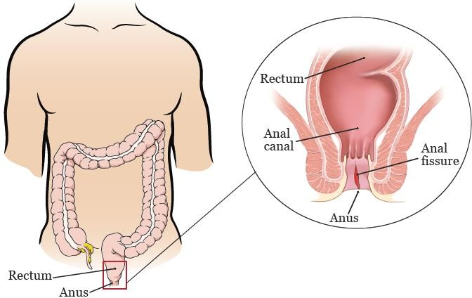

Risk Factor:
- Constipation
- Dehydration
- Inflammatory bowel disease
- Difficult complicated childbirth.
- Trauma.
- Chronic overuse or misuse of stimulant laxatives, which can lead to unpredictable, forceful bowel movements and rebound constipation, disrupting normal defecation patterns. (Clarification: this replaces the original, physiologically inaccurate statement that laxative overuse dehydrates stool; in fact, laxative dependence more often causes erratic bowel habits and straining, which are the true risk factors for fissure formation.)

Clinical Feature:
- Intense pain post-defecation (The most common presenting feature).
- Bleeding (commonly bright red blood on wiping)
- Itching, both typically post-defecation.

Complications:
- Infection of the fissure
- pus formation
- Chronic fissure
- Fistula

Management
- Inspection and no digital rectal examination If the diagnosis is uncertain, or if the fissure is atypical (off midline, multiple, or painless), examination under anesthesia with biopsy may be required to exclude other pathology.

Medical Management:
- Dietary modification such as increasing fiber and fluid intake.
- Stool softening laxatives (such as Movicol or Lactulose) can be trialed if there is no change in stool following initial conservative management.
- Topical anesthetics, such as lidocaine,
- Hot baths can help to relax the anal sphincter and also help the healing process.

- If patients are still symptomatic, the next line of management is GTN cream or diltiazem cream. This increases the blood supply to the region and relaxes the internal anal sphincter, putting less pressure on the fissure, promoting healing and reducing pain. Calcium channel blockers (e.g., topical diltiazem or nifedipine) are now preferred by many guidelines (ASCRS, 2017) as first-line pharmacologic therapy over glyceryl trinitrate (GTN), because they are equally effective with a markedly lower incidence of headache. Botulinum toxin (Botox) injection into the internal sphincter is a further option for fissures refractory to topical therapy, offering temporary chemical sphincter relaxation before surgery is considered.

Surgical Management:
Surgical therapy is reserved for chronic fissures where medical management has failed to resolve the symptoms.
Lateral internal sphincterotomy (LIS) is the surgical gold standard for chronic anal fissure. It achieves healing rates greater than 90%; however, patients must be counseled about a small but recognized risk of flatal or fecal incontinence (particularly in patients with pre-existing sphincter weakness, such as multiparous women), which should be weighed against the benefits during informed consent.

Nursing care:
- Frequent observation of the discharge from perineal area.
- Health education for gentle perineal hygiene and dryness.
- Wear cotton clothes.
- Sitz baths.
- Remove the pack as ordered after warm sitz bath gently.
- Avoid strain as in constipation, accumulation of gases…etc.
- Increase fiber and fluid intake.
- Avoid overuse of laxatives.

Hemorrhoids (piles):
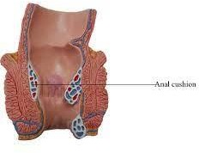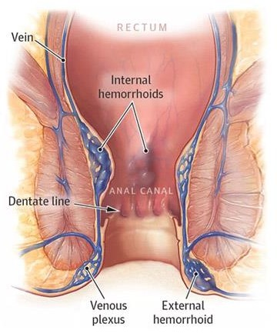Abnormal swelling or enlargement of the anal vascular cushions. The anal vascular cushions act to assist the anal sphincter in maintaining continence. There are three vascular cushions in the anus. These cushions (typically located in the left lateral, right anterior, and right posterior positions) normally contribute up to 15-20% of resting anal canal pressure and help achieve a fine seal for continence of gas and liquid stool; hemorrhoidal disease results from abnormal downward displacement (prolapse) and engorgement of this normal vascular tissue, not from the formation of new blood vessels.

Hemorrhoids are classified to:
-Internal hemorrhoids: hemorrhoids located above the internal sphincter.
-External hemorrhoids: hemorrhoids located outside the external sphincter.CORRECTION: External hemorrhoids are NOT staged by degree of prolapse; only internal hemorrhoids are graded this way. The table below (Goligher's classification) applies specifically to internal hemorrhoids. External hemorrhoids are instead classified simply as thrombosed or non-thrombosed, since their main clinical problem is acute painful thrombosis rather than prolapse.

Classification | Description
1st Degree | Remain in the rectum.
2nd Degree | Prolapse through the anus on defecation but spontaneously reduce.
3rd Degree | Prolapse through the anus on defecation but require digital reduction.
4th Degree | Remain persistently prolapsed.

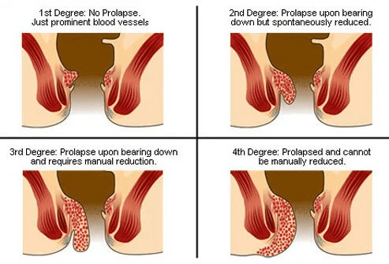

Goligher's Classification of Internal Hemorrhoids (by degree of prolapse):

Risk Factors:
- Excessive straining (from chronic constipation), Low dietary fiber intake and a sedentary lifestyle are also major contributing risk factors.
- Increasing age,
- Raised intra-abdominal pressure (such as pregnancy, chronic cough, or ascites).
- Other less common risk factors include (pelvic or abdominal masses, family history).

Clinical Feature: -
- Painless bright red rectal bleeding, commonly after defecation Importantly, blood is seen on the surface of the stool, not mixed in. (This distinguishes hemorrhoidal bleeding from diverticular or malignant lower gastrointestinal bleeding, which is more often mixed within the stool; any rectal bleeding in a patient over 45-50 years, or with alarm features such as weight loss, anemia, or change in bowel habit, warrants colonoscopy to exclude colorectal cancer before attributing bleeding to hemorrhoids.)
- Pruritus (due to chronic mucus discharge and irritation),
- Rectal fullness or an anal lump.
- Large prolapsed hemorrhoids can thrombose. These are very painful and these patients frequently present acutely as an emergency patient.

Complication:
- Anemia.
- Blood clots in external hemorrhoids.
- Infection.
- Strangulated hemorrhoids (muscles in the anus cut off blood flow to a prolapsed hemorrhoid).

Diagnosis and non-surgical (office-based) management: (Note: this heading has been corrected from 'Medical management' - the procedures listed below are minimally invasive, office-based procedures rather than pharmacologic therapy.)
Diagnosis through inspection, digital rectal examination, proctoscopy, or sigmoidoscopy.
Nonsurgical treatment to attach the mucosa to the underlying muscle to prevent hemorrhoids prolapse:
- Infrared photocoagulation.
- Bipolar diathermy.
- Laser therapy
- Injection of sclerosing agents is also effective for small, bleeding hemorrhoids.

Surgical treatment: (Note: rubber-band ligation has been reclassified below, under non-surgical/office-based management, consistent with current guidelines; cryosurgical hemorrhoidectomy is an outdated technique rarely used today due to unpredictable tissue destruction and prolonged wound healing.)
- Rubber-band ligation. Rubber-band ligation is more accurately classified as an office-based/non-surgical procedure (commonly used for grade I-III internal hemorrhoids) and is usually listed alongside infrared photocoagulation and sclerotherapy above; it is retained in this list per the original outline but should be taught as non-operative.
- Cryosurgical hemorrhoidectomy. - largely superseded by modern techniques and rarely performed today.
- Stapled hemorrhoidopexy/ or Hemorrhoidectomy. Additional current options include Doppler-guided transanal hemorrhoidal dearterialization (THD/HAL), which ligates the terminal branches of the superior rectal artery under ultrasound guidance with less postoperative pain than traditional hemorrhoidectomy.

Nursing care: -
- Gentle perineal hygiene and dryness.
- Avoid excessive straining during defecation.
- A high-residue bulk-forming diet that contains fruit and bran.
- Increased fluid intake.
- Avoid constipation.
- Warm compresses and sitz baths.
- Analgesic ointments and suppositories, astringents (cause shrinking of the piles).
- Encourage bed rest. After hemorrhoidectomy, monitor for urinary retention (common due to peri-anal pain and reflex sphincter spasm) and for delayed hemorrhage, which classically occurs 7-10 days postoperatively as the wound eschar separates.

General education of patients with anorectal condition:
- Patient education is essential to facilitate recovery at home. Written discharge instructions, in addition to verbal teaching, improve retention and adherence, particularly given that pain and anxiety at discharge can impair information recall.
- The nurse instructs the patient to keep the perianal area as clean as possible by gently cleansing with warm water and then drying with absorbent cotton wipes.
- The patient should avoid rubbing the area with toilet tissue.
- Instructions are provided about how to take a sitz bath and how to test the temperature of the water.
- During the first 24 hours after rectal surgery, painful spasms of the sphincter and perineal muscles may occur.
- The nurse instructs the patient that ice and analgesic ointments may decrease the pain. Warm compresses may promote circulation and soothe irritated tissues.
- Sitz baths taken 3 to 4 times each day can relieve soreness and pain by relaxing sphincter spasm.
- Twenty-four hours after surgery, topical anesthetic agents may be beneficial in relieving local irritation and soreness.

Instruct the patient to seek prompt medical attention for red-flag symptoms: fever >38°C, uncontrolled or heavy rectal bleeding, inability to urinate, increasing pain unrelieved by analgesia, or foul-smelling discharge, as these may indicate infection or a surgical complication.
- Medications may include topical anesthetics (i.e., suppositories), astringents, antiseptics, tranquilizers, and antiemetic agents.
- Patients are more adherent and less apprehensive if they are free of pain. 11.Wet dressings saturated with equal parts of cold water and witch hazel help
relieve edema.
- When wet compresses are being used continuously, petrolatum is applied around the anal area to prevent skin maceration.
- The patient is instructed to assume a prone position at intervals because this position reduces edema of the tissue.

Reinforce dietary counseling: a target of 25-30 g of fiber per day, 8-10 cups (about 2-3 liters) of fluid daily, and regular physical activity to prevent constipation and reduce recurrence risk of hemorrhoids and fissures.
Advise against prolonged straining or sitting on the toilet (e.g., avoid reading on the toilet), which raises intra-abdominal and anal venous pressure and worsens hemorrhoidal disease.

Common nursing diagnosis with anorectal disorders:

Constipation (relative) related to
Ignore the urge to defecate due to pain /or Fear from pain.

As evidenced by patient report that
Doesn't pass stool since……days/ Passage of hard, formed stool/or Abdominal distention/ or A feeling of rectal fullness.

Nursing goal: (patient will be)
normal elimination pattern reestablished and maintained.

Pain(acute/ chronic) related to
Rectal swelling or spasm/ or inflammation and edema of prolapsed varices.

As evidenced by
Verbalization of pain/ or fascial expression.

Nursing goal: (patient will be):
Patient will report pain is decreased.
- Alteration in Comfort related to
presence of pain and distress secondary to hemorrhoids

as evidenced by

verbalization of exhaustion, rapid breathing, irritability, and restlessness.

Nursing goal: (patient will be)
report improvement in pain and discomfort brought by hemorrhoids.
be knowledgeable about different comfort measures to relieve hemorrhoid pain.

Additional Evidence-Based Nursing Diagnoses (NANDA-I, 2021-2023):
Nursing Diagnosis | Related To / As Evidenced By | Expected Outcome
Acute Pain | Related to tissue trauma, inflammation, or sphincter spasm; as evidenced by verbal report of pain, guarding behavior, and facial grimacing. | Patient reports pain controlled to a tolerable level (e.g., ≤3/10) within the expected timeframe.
Anxiety | Related to anticipated pain during defecation or dressing changes, embarrassment, or an upcoming surgical procedure; as evidenced by restlessness, reluctance to defecate, or expressed worry. | Patient verbalizes reduced anxiety and demonstrates effective coping strategies.
Risk for Infection | Related to open wound/surgical site, fecal contamination of the perianal area, or compromised tissue integrity. | Patient's wound remains free of signs of infection (no fever, purulent discharge, or spreading erythema).
Deficient Knowledge | Related to unfamiliarity with the disease process, wound care, dietary modification, and prevention of recurrence. | Patient verbalizes and demonstrates correct self-care measures before discharge.
Disturbed Body Image | Related to chronic drainage, odor, or altered bowel function associated with fistula or recurrent hemorrhoidal disease; as evidenced by verbalized embarrassment or social withdrawal. | Patient expresses acceptance of current body function and identifies effective coping strategies.

References (Added - 2024 Evidence-Based Update):
American Society of Colon and Rectal Surgeons (ASCRS). (2017). Clinical practice guideline for the management of anal fissures. Diseases of the Colon & Rectum, 60(1), 7-14.
American Society of Colon and Rectal Surgeons (ASCRS). (2018). Clinical practice guideline for the management of hemorrhoids. Diseases of the Colon & Rectum, 61(3), 284-292.
American Society of Colon and Rectal Surgeons (ASCRS). (2022). Clinical practice guideline for the management of anorectal abscess, fistula-in-ano, and rectovaginal fistula. Diseases of the Colon & Rectum, 65(8), 964-985.
Lohsiriwat, V. (2012). Hemorrhoids: From basic pathophysiology to clinical management. World Journal of Gastroenterology, 18(17), 2009-2017.
Sun, Z., & Migaly, J. (2016). Review of hemorrhoid disease: Presentation and management. Clinics in Colon and Rectal Surgery, 29(1), 22-29.
Herdman, T. H., Kamitsuru, S., & Lopes, C. T. (Eds.). (2021). NANDA International nursing diagnoses: Definitions and classification, 2021-2023 (12th ed.). Thieme.
Hinkle, J. L., & Cheever, K. H. (2022). Brunner & Suddarth's textbook of medical-surgical nursing (15th ed.). Wolters Kluwer.

